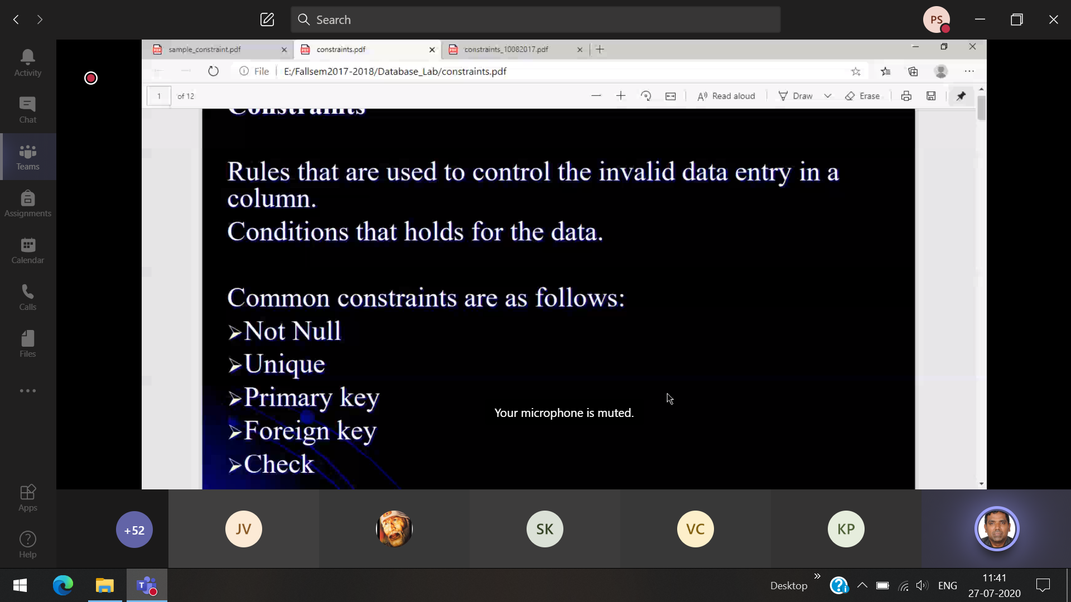

**Not Null**

**Primary-key** will do not duplicate values  
**Unique-key** will accept duplicate values

A table can have only one primary key, more than one unique key

**Foreign key** 🡪 1 table (primary key) another table(foreign key)

Employ table Student table

Employ id(primary key) Student id(primary key)  
 Employ id(foreign key)



**Check constrain**   
Check if the salary>50000  
Check if the CGPA>9

**Default constrain**Whenever a new employ joins, by default he will receive the basic salary(i.e default)

Savepoint, rollback and commit

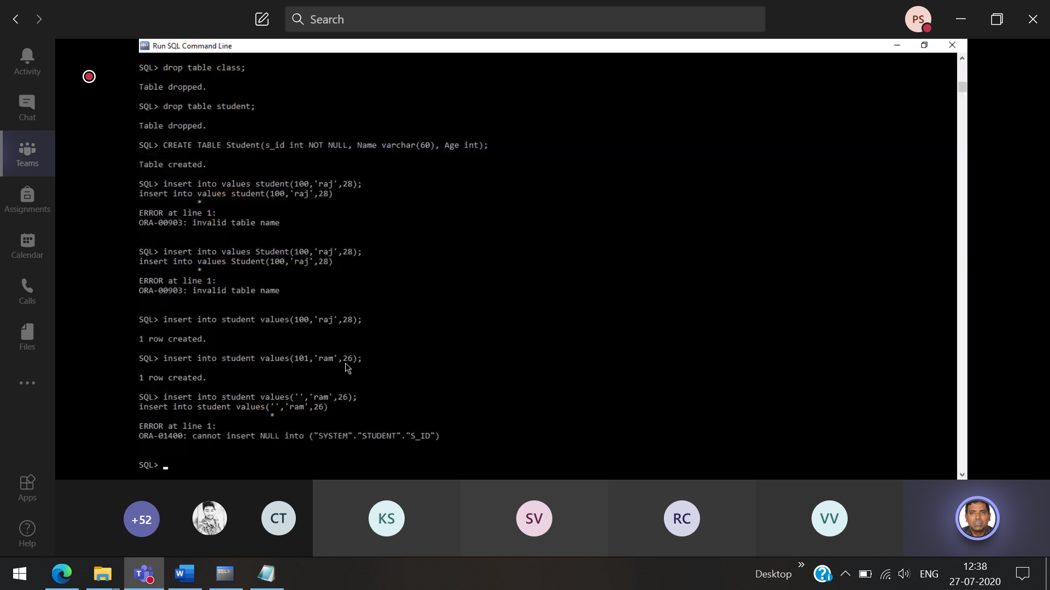

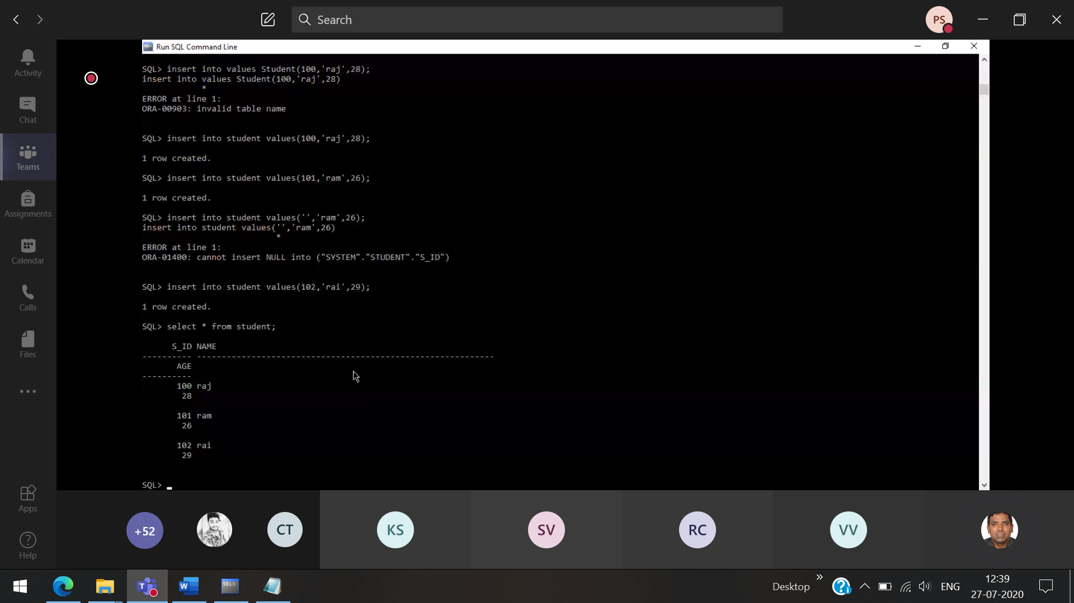

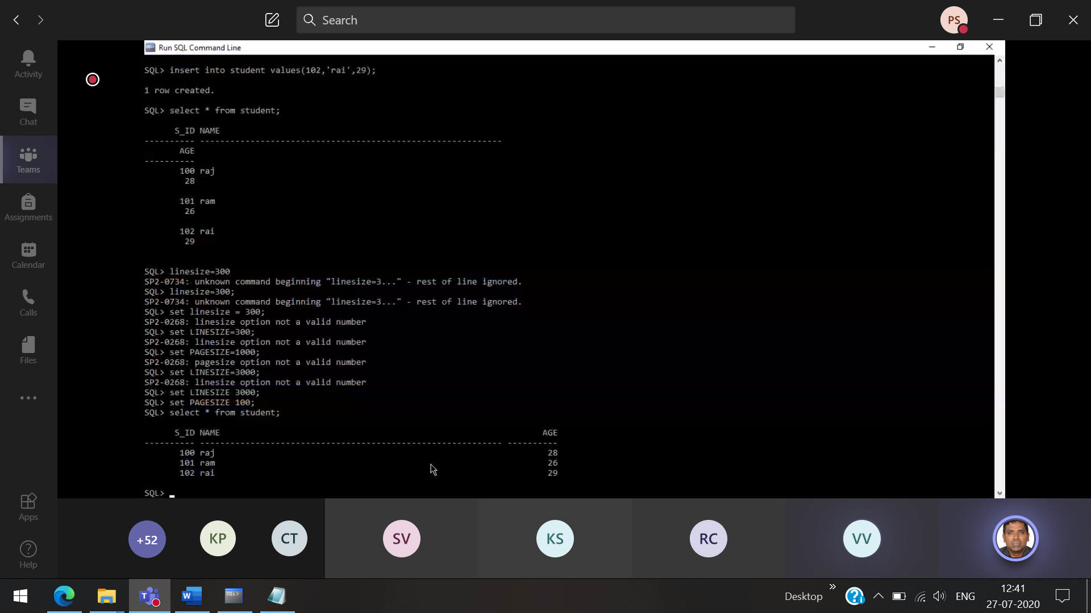

**Adding unique constrain to the student iD 🡪 Will accept only unique values in the unique constrain.**

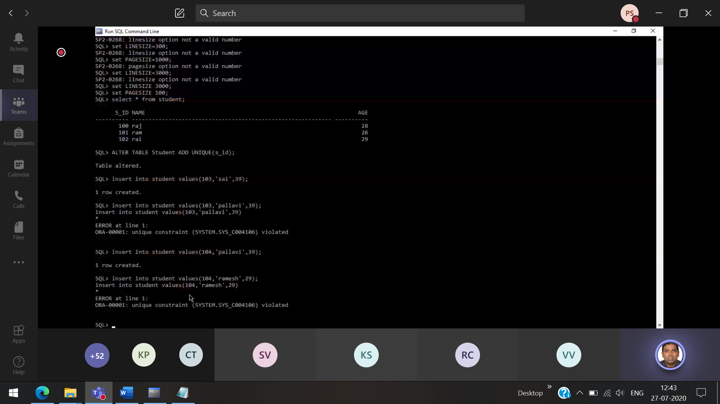

**103 already assigned, when inserting the same value it is firing**

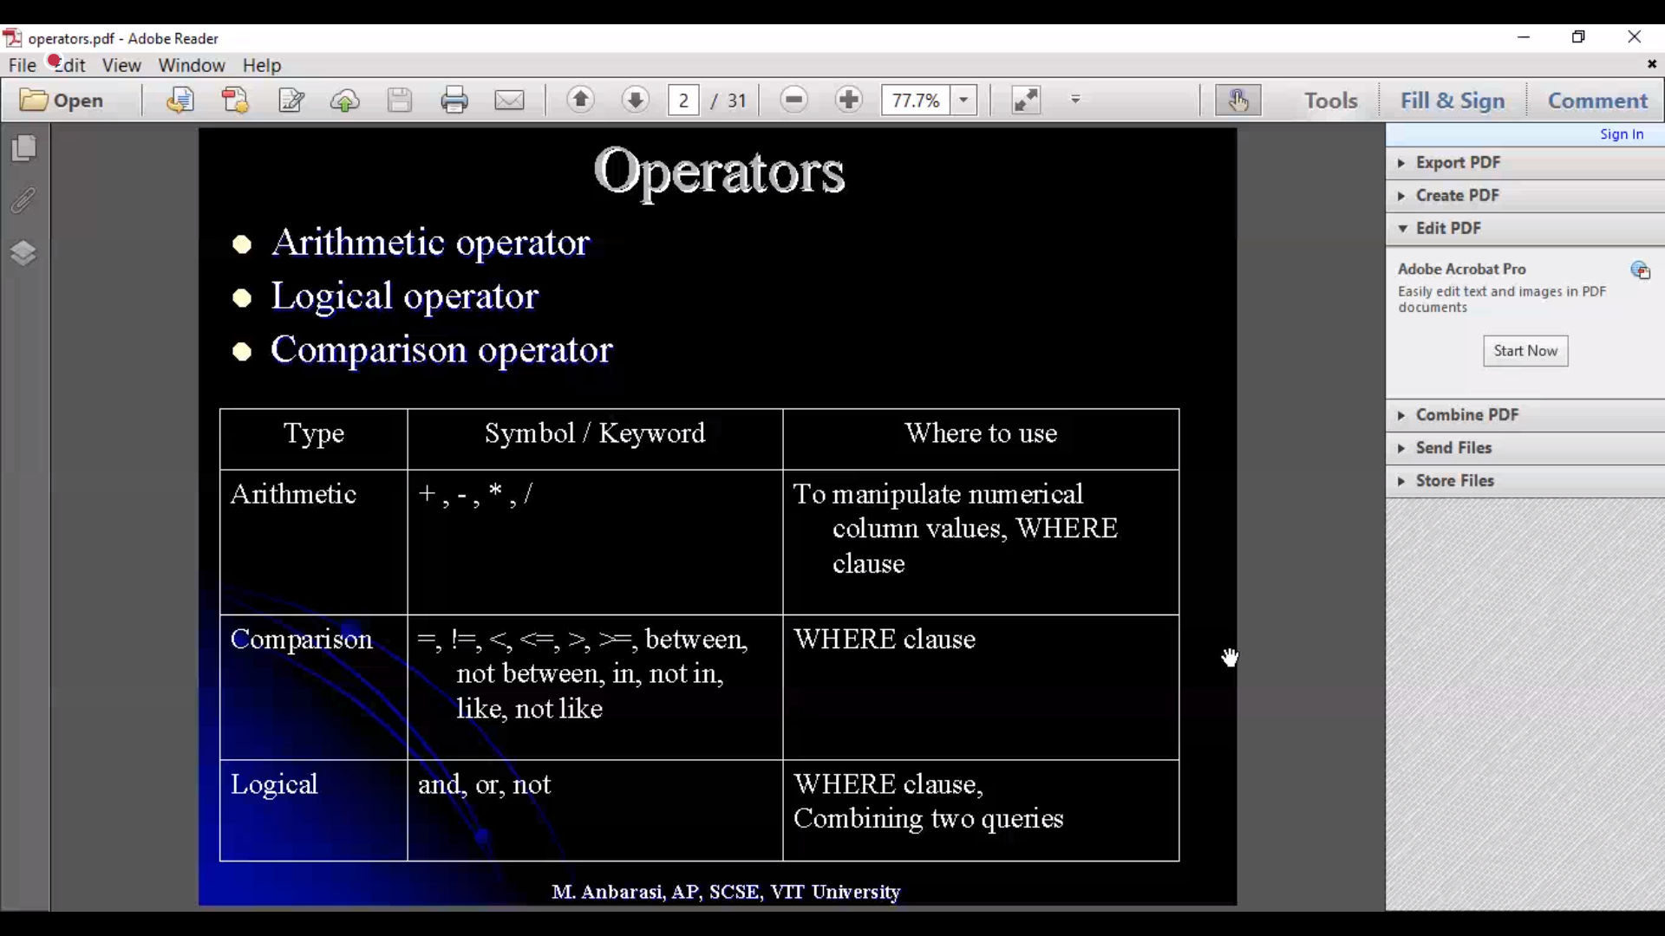

Inner sub query 🡪 Based on this the outer sub query will be executed

Outer sub query 🡪

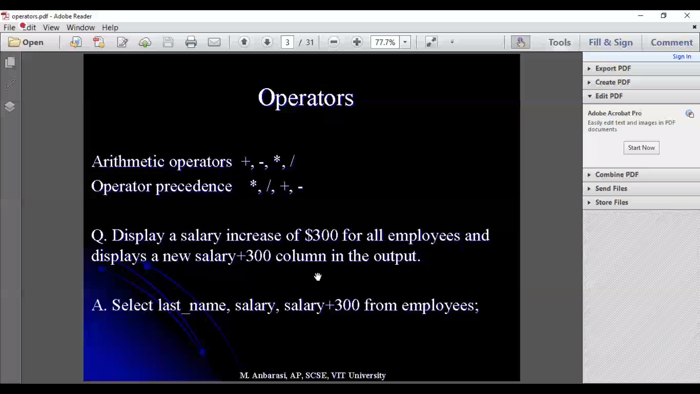

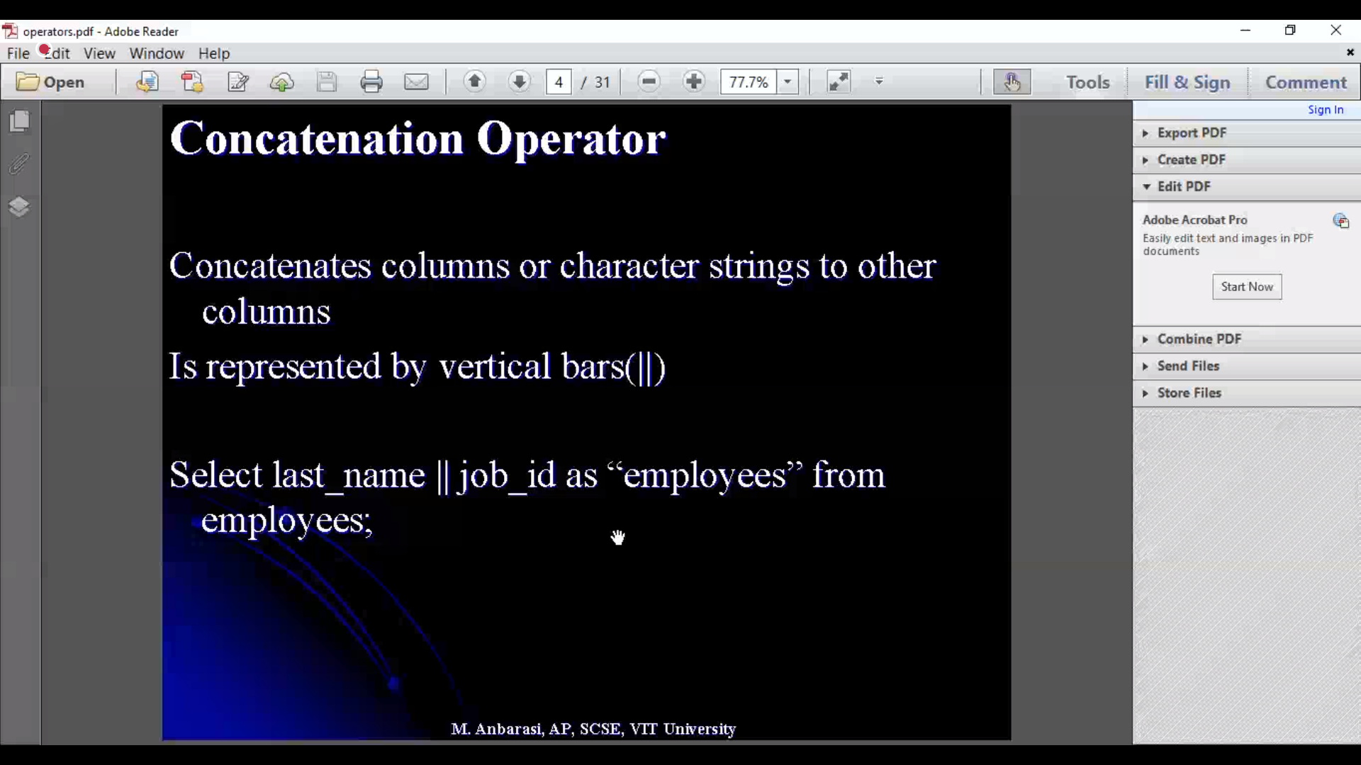

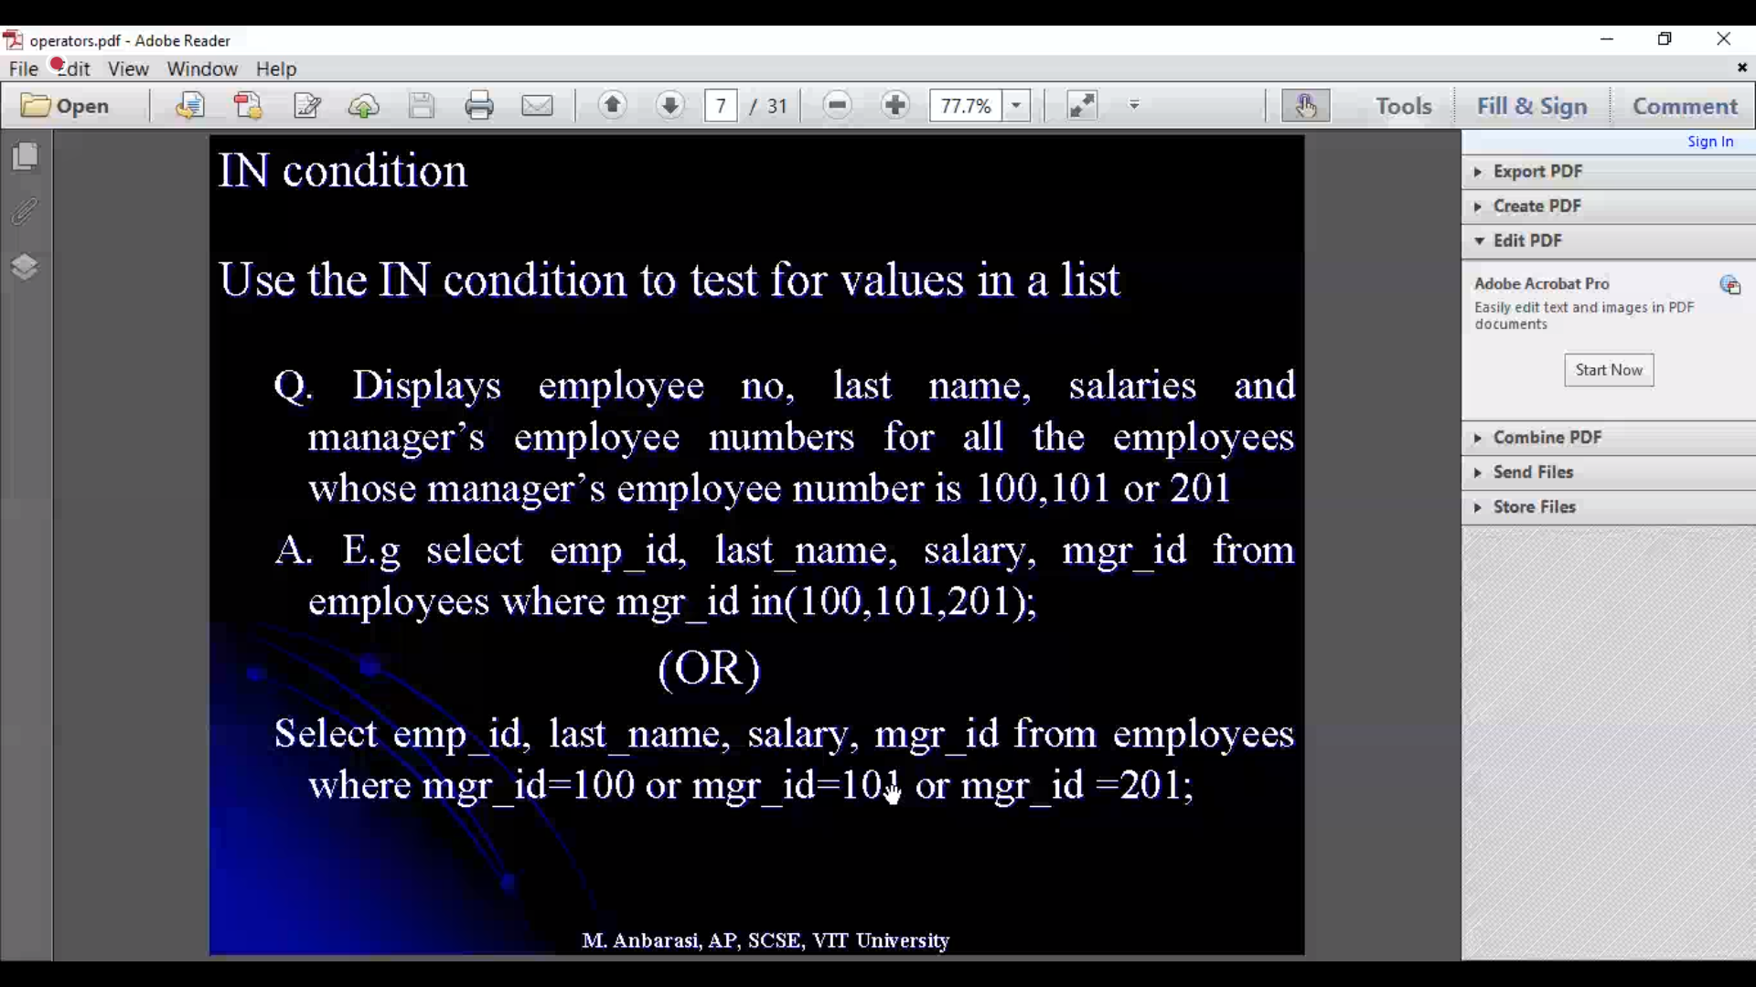

IN 🡪 Similar to OR operator

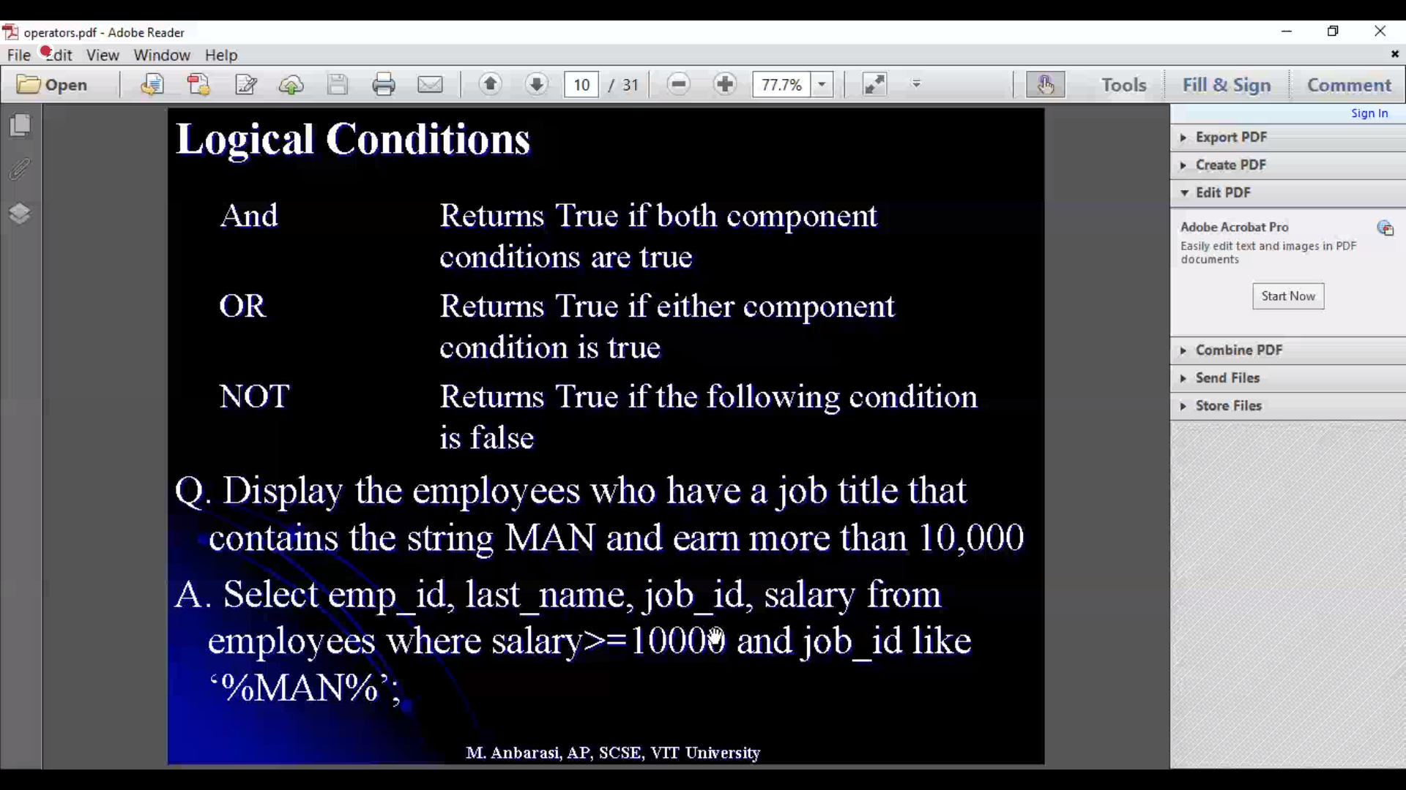

Job id starting in MAN and salary >=1000

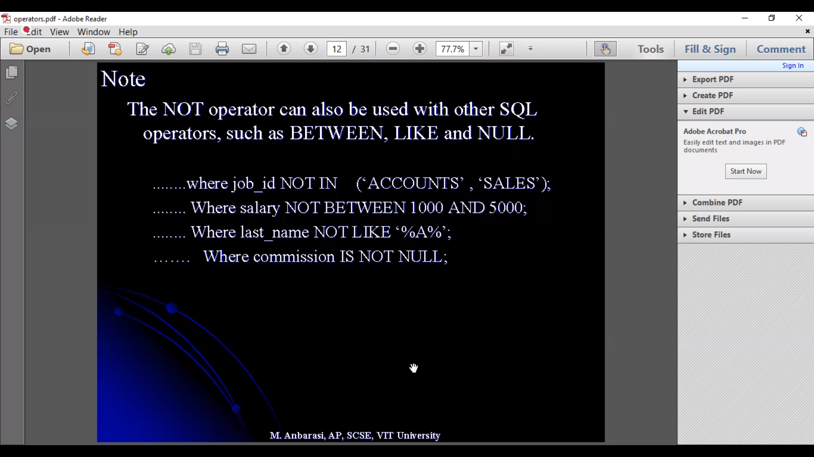

Functions

